**TENSES**

Tenses denote the time of action. They show when the work is done. They are:

1. (1) Present Tense
2. (2) Past Tense
3. (3) Future Tense
4. They are further divided into:

(1) ***Simple Present-***It is used to denote scientific facts, universal truths and work done on daily basis.



**Example** – She writes a letter. I **work**. He **works**. I **go**. He **goes**.

**NEGATIVE RULE ---sub + do/does not + v1 + s/es + object**

**Example** – She does not write a letter. I **don't work**. He **does not work**. I **do not go**. He **doesn't go**.

**INTERROGATIVE RULE ---do/Does + sub + v1 + s/es + object**

**Example** – Does she write a letter? **Do** I **work**? **Does** he **work**? **Do** I **go**? **Does** he **go**?



**Example** – Does she not write a letter?

(2) ***Present Continuous***– It is used to express an action taking place at the time of speaking.

**ASSERTIVE RULE ---sub + is/am/are + v1 + ing + object**

**Example** – she is writing a letter. I **am working**. He**'s working**. I**'m going**. He**'s going**.

**NEGATIVE RULE ---sub + is/am/are + not + v1 + ing + object**

**Example** – She is not writing a letter. I**'m not working**. He **isn't working**. I**'m not going**. He **isn't going**.

**INTERROGATIVE RULE ---is/am/are + sub + v1 + ing + object**

**Example** – Is she writing a letter? **Am** I **working**? **Is** he **working**? **Am** I **going**? **Is** he **going**?



**Example** – Is she not writing a letter?

(3) ***Present Perfect***– It is used to show an action that started in the past and has just finished.

**ASSERTIVE RULE ---sub + has/have + v3 + object**

**Example-**She has written a letter. I **have worked**. He **has worked**. I **have gone**. He **has gone**.

**NEGATIVE RULE ---sub + has/have + not + v3 + object**

**Example** – She has not written a letter. I **haven't worked**. He **hasn’t worked**. I **haven't gone**. He **has not gone**.

**INTERROGATIVE RULE ---has/have + sub + v3 + object**

**Example-**Has she written a letter? **Have** I **worked**? **Has** he **worked**? **Have** I **gone**? **Has** he **gone**?

**INTERROGATIVE NEGATIVE RULE ---has/have + sub + not + v3 + object**

**Example**– Has she not written a letter?

(4) ***Present Perfect Continuous***– This tense shows the action which started in the past and is still continuing.

**ASSERTIVE RULE ---sub + has/have + been + v1 + ing + object**

**Example** – She has been writing a letter. I **have been** work**ing**. He **has been working**. I **have been going**. He **has been** go**ing**.



**Example**– She has not been writing a letter. I haven't been working. He hasn't been working. I haven't been going. He hasn't been going.



**Example** – Has she been writing a letter? Have I been working? Has he been working?



**Example** – Has she not been writing a letter? Have I been going? Has he been going?

**Past Tense**

Tense symbolizes the ever moving, non-stop wheel of time which is forever busy gathering moments of future and throwing them into the dustbin of past

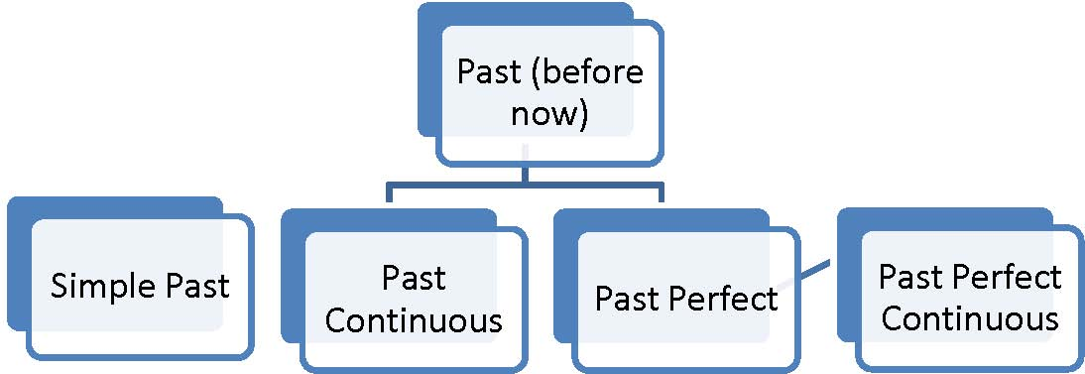

**Simple Past**

Used to indicate an action completed in the past. It often occurs with adverb of time. Sometimes it is used without an adverb of time.

Used for past habits.

Eg. I played football when I was a child.

Rule: **Subject + V2**

Eg She wrote a letter

1.Assertive Sentences –

**Subject + V2 + Object + (.)**

She wrote a letter.

2.Negative Sentences-

**Subject + didn’t + V1 + Object + (.)**

She didn’t.write a letter.

3.Interrogative Sentences-

**Did + Subject + V1 + Object + (?)**

Did she write a letter?

4.Interrogative Negative Sentences-

**Did + Subject + not + V1 + Object + (?)**

Did she not write a letter?

**Past Continuous Tense**

Used to denote an action going on at some time in the past.

e.g. I was driving a car.

Rule: was/were + ing

1.Assertive Sentences –

**Subject + was/were +V1+ ing + Object + (.)**

She was writing a letter.

2.Negative Sentences-

**Subject + was/were + not + ing + Object + (.)**

She was not writing a letter.

3.Interrogative Sentences-

**Was/were + Subject + ing+ Object + (?)**

Was she writing a letter?

4.Interrogative Negative Sentences-

**Was/were + Subject + not + ing+ Object + (?)**

Was she not writing a letter?

**Past Perfect Tense**

Used to describe an action completed before a certain moment in the past, usually a long time ago. If two actions happened in the past, past perfect is used to show the action that took place earlier.

e.g. The patient had died before the doctor came.

1.Assertive Sentences –

**Subject + had + V3 + Object + (.)**

She had written a letter.

2.Negative Sentences-

**Subject + had + not + Object + (.)**

She had not written a letter.

3.Interrogative Sentences-

**Had + Subject + V3 + Object + (?)**

Had she written a letter?

4.Interrogative Negative Sentences-

**Had + Subject + not + V3 + Object + (?)**

Had she not written a letter?

**Past Perfect Continuous Tense**

Used to denote an action that began before a certain point in the past and continued up to some time in past.

e.g. I had been learning English in this school for 20 days.

1.Assertive Sentences –

**Subject + had been +V1 + ing + Object + (.)**

She had been writing a letter.

2.Negative Sentences-

**Subject + had + not been + V1+ ing + Object + (.)**

She had not been writing a letter.

3.Interrogative Sentences-

**Had + Subject+ been+ V1 + ing + Object + (?)**

Had she been writing a letter?

4.Interrogative Negative Sentences-

**Had + Subject +not + been + V1 + ing + Object + (?)**

Had she not been writing a letter?

**FUTURE TENSE**

Time and tide wait for no man. So, a period of time following the moment of speaking or writing is called as future tense.

For e.g-She will write a letter.

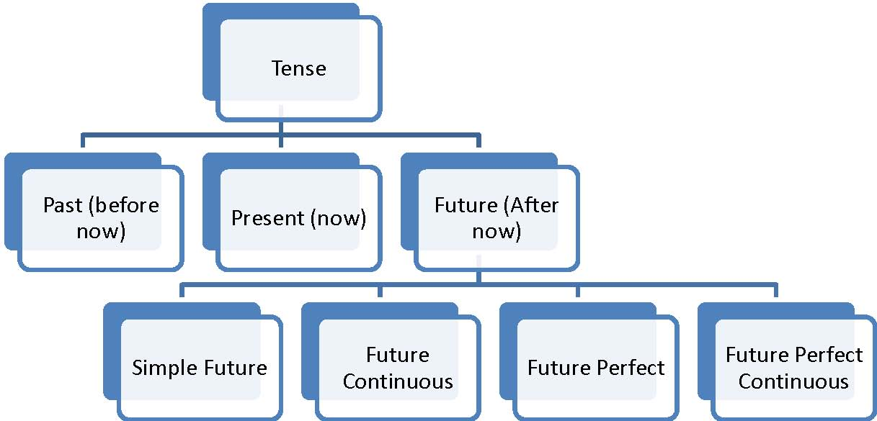

**Simple Future**

This tense tells us about an action which has not occurred yet and will occur after saying or in future

Rule – **Will/Shall + Verb (Ist form)**

In Future Tense helpingverb ‘Shall’ isused with ‘I’ and ‘We’. Helpingverb ‘Will’

is used with all others. When you are to make a commitment or warn someone or

emphasize something, use of 'will/shall' is reversed. ‘Will’ isused with ‘I’ & ‘We’

and 'shall' is used with others.

In general speaking there is hardly any difference between 'shall & will' and

normally ‘Will’ is used with all.

Now, let us use this rule in various forms of sentences;

1.Positive / Affirmative Sentences –

**Subject + Will/Shall + Verb (Ist form) + Object + (.)**

She will write a letter.

2.Negative Sentences-

**Subject + Will/Shall + Not + Verb (Ist form) + Object + (.)**

She will not write a letter.

3.Interrogative Sentences-

**Will/Shall + Subject + Verb (Ist form) + Object + (?)**

Will she write a letter?

4.Interrogative Negative Sentences-

**Will/Shall + Subject + Not + Verb (Ist form) + Object + (?)**

Will she not write a letter?

**Future Continuous Tense**

It is used to express an ongoing or continued action in future.

e.g. He will be distributing sweets in temple tomorrow at 12 o'clock. In the example, the action will start in future (tomorrow) and action is thought to be continued till sometime in future.

We use the future continuous to talk about something that will be in progress at or around a time in the future.

Rule: **Will/Shall + Be + Verb (Ist form) + Ing**

Now, let us use this rule in various forms of sentences;

1.Positive / Affirmative Sentences –

**Subject + Will/Shall + Be + Verb (Ist form) + Ing + Object + (.)**

She will be writing a letter.

2.Negative Sentences-

**Subject + Will/Shall + Not + Be + Verb (Ist form) + Ing + Object + (.)**

She will not be writing a letter.

3.Interrogative Sentences-

**Will/Shall + Subject + Be + Verb (Ist form) + Ing + Object + (?)**

Will she be writing a letter?

4.Interrogative Negative Sentences-

**Will/Shall + Subject + Not + Be + Verb (Ist form) + Ing + Object + (?)**

Will she not be writing a letter?

**Future Perfect Tense**

It is used to express an action which will happen/occur in future and will be completed by a certain time in future.

We use the future perfect to say that something will be finished by a particular time in the future.

e.g. They will have shifted the house by Sunday morning.

Rule: **Will/Shall + Have + Verb (3rd form)**

Now, let us use this rule in various forms of sentences;

1.Positive / Affirmative Sentences –

**Subject + Will/Shall + Have + Verb (3rd form) + Object + (.)**

She will have written a letter.

2.Negative Sentences-

**Subject + Will/Shall + Not + Have + Verb (3rd form) + Object + (.)**

She will not have written a letter.

3.Interrogative Sentences-

**Will/Shall + Subject + Have + Verb (3rd form) + Object + (?)**

Will she have written a letter?

4.Interrogative Negative Sentences-

**Will/Shall + Subject + Not + Have + Verb (3rd form) + Object + (?)**

Will she not have written a letter?

**Future Perfect Continuous Tense**

It is used to talk about actions that will commence at a fix time in future and will continue for some time in future.

If there is no time reference, then it is not a Future perfect continuous tense. Without continued time reference, such sentences are Future Continuous Tense. Continued time reference only differentiates between Future Continuous Tense and Future Perfect Continuous Tense.

The future perfect progressive emphasize the duration of an activity that will be in progress before another time or event in the future.

* 1. e.g. This time tomorrow, I will be enjoying the cricket match in the stadium.
  2. It is also used to talk about planned actions or actions expected to happen.

1. e.g. They will be staying for a week’s

The future perfect progressive emphasize the duration of an activity that will be in progress before another time or event in the future.

Rule: **Will/Shall + Have been + Verb (Ist form) + Ing**

Now, let us use this rule in various forms of sentences;

1.Positive / Affirmative Sentences –

**Subject + Will/Shall + Have been + Verb (Ist form) + Ing + Object + (.)**

She will have been writing a letter.

2.Negative Sentences-

**Subject + Will/Shall + Not + Have been + Verb (Ist form) + Ing + Object+ (.)**

She will not have been writing a letter.

3.Interrogative Sentences-

**Will/Shall + Subject + Have been + Verb (Ist form) + Ing + Object +(?)**

Will she have been writing a letter?

4.Interrogative Negative Sentences-

**Will/Shall + Subject + Not + Have been + Verb (Ist form) + Ing + Object +(?)**

Will she not have been writing a letter?